VECTOR #01

# ***VECTOR #02***

# 

VECTOR #03

VECTOR #04

# ***VECTOR #05***

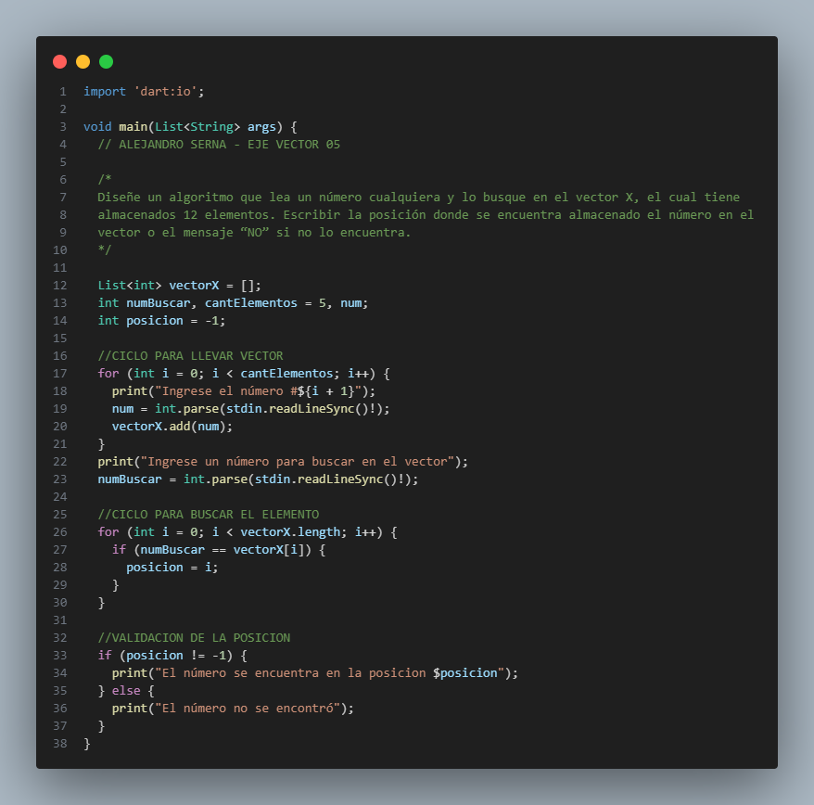

# ***VECTOR #06***

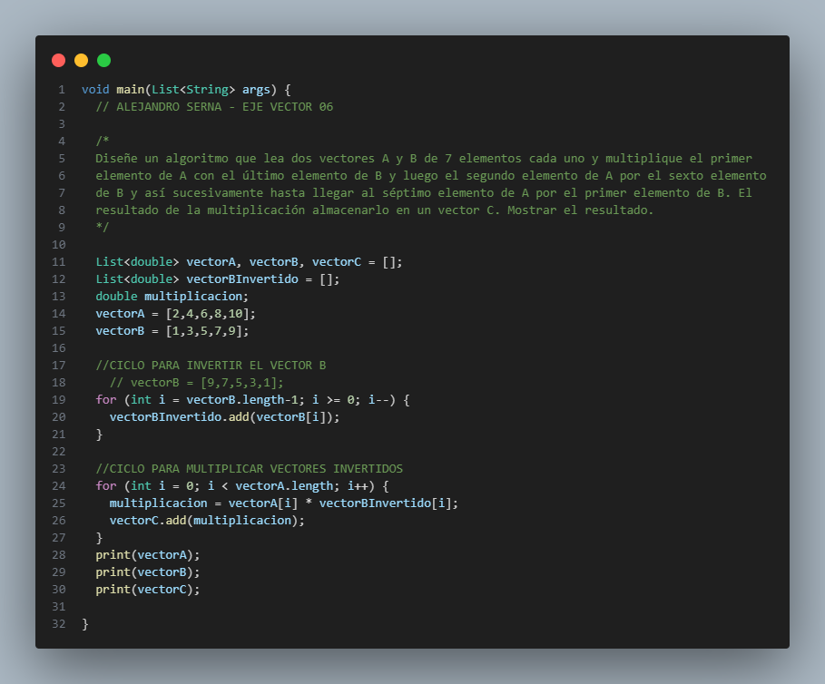

# ***VECTOR #07***

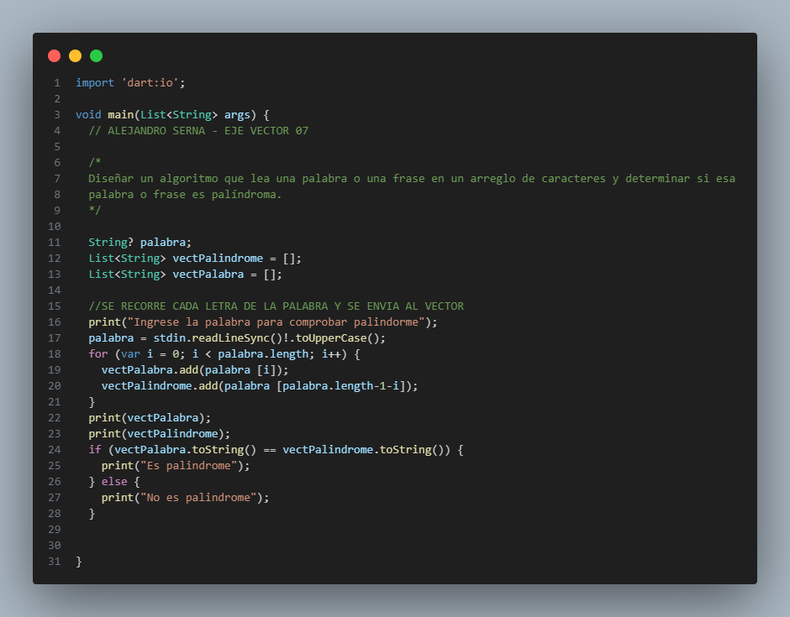

# ***VECTOR #08***

